***Seminar Report***

# On

# Automatic irrigation system

**Submitted By**

**Himanshu P. Khode**

***Seventh Semester***

***B.E.( Electronics and Telecommunication Engineering)***

## Guided by

**DR. N.P. DHOLE**



# Department of Electronics and Telecommunication Engineering,

**Prof. Ram Meghe Institute of Technology & Research, Badnera - Amravati**

# 2021-2022

**CERTIFICATE**

*This is to certify that the seminar report entitled*

*Automatic irrigation system*

*is a bonafide work and it is submitted to the Sant Gadge Baba Amravati University, Amravati*

*By*

HIMANSHU P. KHODE

***Seventh Semester B.E.( Electronics and Telecommunication***

***Engineering )*** *in the partial fulfillment of the requirement for the degree of* ***Bachelor of Engineering*** *in* ***Electronics and Telecommunication***

***Engineering*** *, during the academic year* ***2021-2022*** *under my guidance*.

|  |  |
| --- | --- |
| **DR. N. P. DHOLE** | **Dr. S. M. Deshmukh** |
| *Guide Department of EXTC Engg.*  *PRM Institute Of Technology & Research, Badnera* | *Head, Department of EXTC Engg.*  *PRM Institute Of Technology & Research, Badnera* |



**Department of Electronics and Telecommunication Engineering, Prof. Ram Meghe Institute of Technology & Research, Badnera- Amravati.**

# 2021-2022

## ACKNOWLEDGEMENT

It is our utmost duty and desire to express acknowledgement to the various. torchbearers, who have rendered valuable guidance during preparation of our seminar.

First of all, we extend our deepest gratitude to our revered Principal **Dr. A. P. BODKHE** for implementing seminar scheme in the college with enthusiasm.

We are grateful to **DR. S. M. DESHMUKH**, HOD, Department of Electronics & Telecommunication and **DR N. P. DHOLE**, our Guide for providing immense support and guidance. We are beholden for guiding us at every step in the project. She has most honestly guided us throughout; never leaving us unanswered for any of our doubts. It was her constant persuasion, encouragement, inspiration and able guidance that helped us in completing our task successfully. I owe an incalculable debt to all staffs of the Electronics and Telecommunication Department of for their direct and indirect help.

My thanks and appreciations also go to all colleague in developing the project and people who have willingly helped me out with their abilities and recommendations for making this concept even better.

Name of Student

Himanshu P. Khode



**ABSTRACT**

The water irrigation system is introduced to optimize the use of water supply for agricultural crops. This project made to design the water irrigation system based on Arduino microcontroller board. In area where low rain occurs or in case of inadequate rain take place, irrigation becomes difficult. The need to automated for proper water supply and reduce farmer time and work. In case the farmer is not available for irrigation every time, then this system is very useful. So, efficient water management makes an important role in the irrigated agricultural systems. This project is to design and develop a low-cost system which is based on water irrigation system using Arduino board. This project uses temperature and soil moisture sensors to detect the water quantity present in agriculture field. The project uses Arduino micro controller which is controller to the whole process of irrigation. The aim of the implementation was to demonstrate that the water irrigation can be used to reduce water use.

## 

## TABLE OF CONTENT

|  |
| --- |
| LIST OF FIGURES |
| INTRODUCTION |
| METHODOLOGY |
| 1.2 LITERATURE SURVEY |
| LIST OF COMPONENTS |
| COMPONENTS DESCRIPTION |
| 3.1 ARDUINO MICRO-CONTROLLER |
| SOIL MOISTURE SENSOR |
| HUMIDITY SENSOR |
| 3.4 WATER PUMP |
| 3.5 LCD PANNEL |
| BLOCK DAIGRAM |
| 4.1 BLOCK DAIGRAM OF PROPOSED SYSTEM |
| 4.2 BLOCK DAIGRAM DESCRIPTION |
| SOFTWARE USED |
| ADVANTAGES AND DISADVANTAGES |
| CONCLUSION |
| REFRENCE |

## TABLE OF CONTENT

**List of figures**

1. Introduction 1
   1. Literature survey 3
2. List of Components 4
3. Components Description 5
   1. Ultrasonic sensor 5
   2. Microcontroller 8051 6
   3. GSM Module 7
   4. LCD Module 8
4. Block Diagram 9
   1. Block Diagram of Proposed System 9
   2. Block Diagram Description 10
5. Software Used 11
6. Advantages and Disadvantages 12
7. Conclusion 13
8. Reference 14

## LIST OF FIGURES

|  |  |  |
| --- | --- | --- |
| Figure no. | Caption | Page no. |
|  |  |  |
| 3.3.1 | Arduino Micro-controller | 5 |
| 3.3.2 | Soil Moisture Sensor | 6 |
| 3.3.3 | Humidity Sensor | 7 |
| 3.3.4 | Water Pump | 8 |
| 3.3.5 | LCD Module | 9 |
| 4.4.1 | Block diagram of proposed system | 10 |

## INTRODUCTION

Agriculture is depending on the rain which is not sufficient sources of water for whole irrigation for the agricultural crops. The irrigation system helps to supply water to fields according to the moisture of soil. Rain plays a vital role in irrigation; water supply is required because of most of the fields are depends on the rain. In conventional system the farmer has to work properly and with a full care of water supply for watering the crops, which is depend on crops types. Insufficient watering causes ruin to plants. To provides proper and needed amount of water for different region and avert the water overflow at the sloppy areas and considering the situation of farmer, the water irrigation system will be most useful for proper irrigation. The proper water supply system is the major examine in cropping system. An irrigation process is useful to reduce water use for agricultural crops which is a much-required process. The need of water irrigation system is to prevail over irrigation and under irrigation. Over irrigation occurs because of bad distribution of water and chemical which fed to water pollution. Under irrigation proceed to increased soil salinity with buildup of toxic salts on the soil surface in region with high evaporation. To overcome these problems and to minimize the man power by smart irrigation system has been used. To Overcoming these limitation new techniques are been implementing in the irrigation system, through which small amounts of water supply to the parts of root of a plant. The plant soil moisture stress is cure by providing proper amount of water resources frequently by which the moisture condition of the soil will retain better growth. The full concept of the water irrigation system is like traditional techniques of sprinkler or surface irrigation requires half of water sources. Even more specific amounts of water can be supplied for plants. The main objective of this project is to save water and reduce or minimize labor work in the agriculture lands. Continuously Monitoring the status of sensors provide signal for taking necessary action to implementing the process and get the output of soil moisture sensor & provide water according to the need or required of crop

### METHODOLOGY

Physical layer is soil moisture sensor which collects the data by detecting environmental conditions, in this case its moisture of soil and fed the information to the microcontroller where the processing of that information will take place to convert it into relevant data. This processing comes under decision making layer where the program logic takes its role. The automatic irrigation system was designed to continuously sense the moisture and temperature level of the soil. The system responds appropriately by watering the soil with the exact amount of water required and then shuts down the water supply when the required amount of soil moisture is achieved.

The reference amount of soil moisture is already fed to the microcontroller beforehand. This reference soil moisture content was made to be adjustable for the three most common soil types (sandy, loamy and clayey soils).The moisture sensors and temperature sensors were designed using probes that are made from corrosion resistant material which can be pinned into soil sample test and voltage levels corresponding to the wet and dry condition of the soil test were implemented by measuring the resistance between the moisture probes and matching them to output voltage of a comparator circuit.

The main objective of this project is to automate the process of irrigating the plants. The procedure could also improve the current methods of automatic irrigation systems by introducing the new matrix system thereby reducing the labor and also the total amount of necessary for the whole procedure. The process involves the moisture sensor to analyze the amount of moisture in the soil and then if the moisture in the soil is low. the processor then produces an output signal that informs the water valve to open and reach the right destination to give the maximum effect. Thus, this system gives a very efficient way of irrigating the plants automatically without any human intervention.

### LITERATURE SURVEY

Archana and Priya (2016) proposed a paper in which the humidity and soil moisture sensors are placed in the root zone of the plant. Based on the sensed values the microcontroller is used to control the supply of water to the field. This system doesn’t intimate the farmer about the field status [1].

SonaliD.Gainwar and Dinesh V. Rojatkar (2015) proposed a paper in which soil parameters such as pH, humidity, moisture and temperature are measured for getting high yield from soil. This system is fully automated which turns the motor pump ON/OFF as per the level of moisture in the soil. The current field status is not intimated to the farmer [2].

V. R. Balaji and M. Sudha (2016) proposed a paper in which the system derives power from sunlight though photovoltaic cells. This system doesn’t depend on electricity. The soil moisture sensor has been used and based on the sensed values PIC microcontroller is used to ON/OFF the motor pump. Weather forecasting is not included in this system [3]

G. Parameswaran and K. Sivaprasath (2016) proposed a smart drip irrigation system using IOT in which humidity, temperature and pH sensors are used. Irrigation status is updated to the server or local host using personal computer. The farmer can’t access about the field condition without internet [4].

## LIST OF COMPONENTS

Arduino Micro-controller

Soil Moisture Sensor

Humidity Sensor

WATER PUMP

LCD PANNEL

## COMPONENTS DESCRIPTION

### Arduino Micro-controller

### Arduino is an open-source which provide prototyping platform based on easy-to-use software and hardware. Arduino boards are able to read inputs - a finger on a button, light on a sensor - and turn it into an output - turning on an LED, activating a motor, publishing acceptably online. We can tell board what to do by sending a set of instructions to the microcontroller board. To do so we use the Arduino Software (IDE), and the Arduino programming language (based on wiring), based on Processing. The Arduino Uno can be powered via with an external power supply or the USB connection.

### The power source is selected automatically External or non-USB power can come either from an AC-to-DC adapter or battery. The adapter is |will be connected by plugging a 2.1mm center-positive plug into the board's power jack. Leads from electric battery are often, may be inserted within the Gnd and Vin pin headers of the power connector. The board will operate on, care for Associate in Nursing external provide of six to twenty volts. If provided with less than 7V, however, the 5V pin may provide less than 5 volts and therefore the board is also unstable. If exploitation over 12V, the voltage could overheat and harm the board. The suggested range is seven to twelve volts.

### 

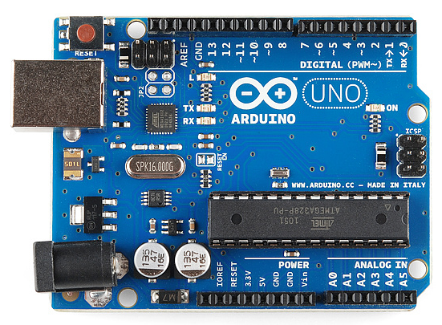

Fig 3.1.1: Arduino Micro-controller

### Soil Moisture Sensor

### Although soil water status will be determined by direct (soil sampling) and indirect (soil moisture sensing) ways, direct methods of observing soil moisture aren't usually used for irrigation planning because they're intrusive and labor intensive and can't offer immediate feedback. Soil wetness probes is may be for good put in at representative points in an agricultural field to supply continual wetness readings over time which will be used for irrigation management. Special care is required when exploitation soil moisture devices in coarse soils since most devices require close contact with the soil matrix that's generally troublesome to achieve in these soils. Most of the presently available volumetrically sensors appropriate for irrigation are insulator.

### This cluster of sensors estimate soil water content by measurement the soil bulk permittivity (or non-conductor constant) that determines the speed of an Associate in Nursing electromagnetic radiation, non-particulate radiation or pulse through the soil. during a material stuff just like the soil (i.e., created from totally different elements like minerals, air and water), the worth of the permittivity is formed up by the relative contribution of every of the elements.

### Since the insulator or non-conductor constant of liquid water is far larger than that of the opposite soil constituents, the entire permittivity of the soil or bulk permittivity is principally ruled by the presence of liquid water. The insulator or non-conductor ways use empirical (calibrated) relationships between volumetrically water content and therefore the detector output signal (time, frequency, impedance, wave phase).

### These techniques are getting wide adopted as a result of they need sensible| reaction time (almost fast measurements), don't need maintenance, and may give continuous readings through automation. though these sensors are supported the insulator principle the varied varieties out there or accessible (frequency domain reflectometry- FDR, capacitance, time domain transmission-TDT, amplitude domain reflectometry-ADR, time domain reflectometry-TDR, and section transmission) gift necessary variations in terms of standardization needs accuracy, installation and maintenance needs and value.

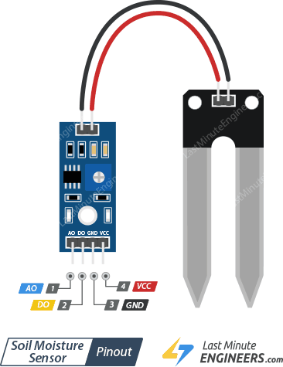

Fig. 3.3.2: Soil Moisture Sensor

### Humidity Sensor

A humidity or humidness sensor or detector also referred to as a hygrometer measure frequently reports the humidity within the air. A humidity sensor senses relative this suggests that it measures each air temperature and wet. relative humidity expressed as a percent, is that the magnitude relation of actual wetness within the air to the very best quantity of moisture air at that temperature will hold. The hotter the air is, the additional wet it will hold, therefore relative humidity changes with fluctuations in temperature. The foremost common kind of humidity detector uses what's referred to as “capacitive measuring this technique depends on electrical capacitance, or the flexibility of two near electrical conductors to form an Associate in Nursing degree electrical field between them. The sensing itself consists of two metal plates with a nonconductive compound film between them. The film collects wet from the air, and therefore the wet causes minute changes within the voltage between the 2 plates. The changes in voltage are converted into digital readings showing the quantity of wet within the air.

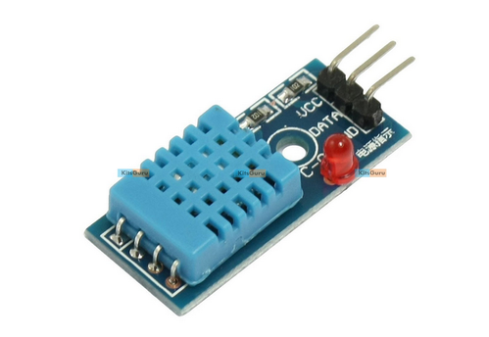

Fig 3.3.3 Humidity Sensor

### Water Pump

### The pump is employed to by artificial water for a selected task. It is often electronically controlled by interfacing it to a microcontroller. It is often triggered ON/OFF by causing signals pro Renata. the method of by artificial means activity water is understood as pumping. There are many sorts of water pumps used. This project employs the employment of a little pump that is connected to a H-Bridge. The pumping of water could be a basic and sensible technique, much more sensible than scooping it up with one's hands or lifting it in a very hand-held bucket. This is true whether or not the water is drawn from a contemporary supply, affected to a required location, purified, or used for irrigation, washing, or waste product treatment, or for evacuating water from associate undesirable location. notwithstanding the result, the energy needed to pump water is an especially exigent part of. All alternative processes rely or profit either from water descending from the next elevation or some pressurized utility.

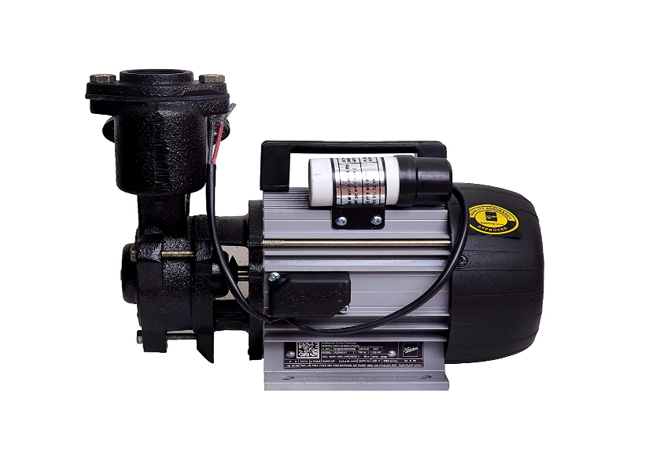

FIG 3.3.5: Water Pump

* 1. **LCD Module**

A liquid-crystal show (LCD) could be a flat-panel display or different electronic visual show that uses the light modulating properties of liquid crystals. Liquid crystals don't emit light-weight directly. LCDs are accessible to display arbitrary images(as) in an exceedingly, in a very all-purpose pc or laptop display) or mounted pictures with low info content, which may be displayed or hidden, like predetermined words, digits, and 7-segment displays as during a in a very digital clock. They use an equivalent basic technology, except that arbitrary picture are created from a larger variety of tiny pixels, whereas different displays have larger components.

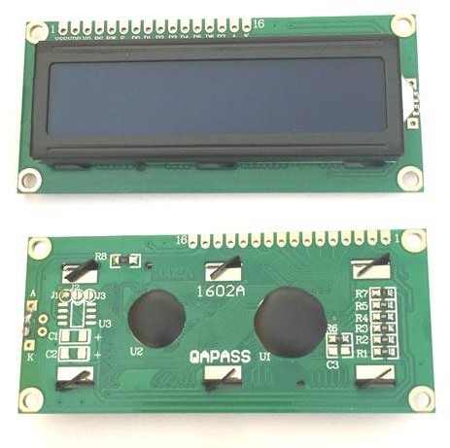

FIG 3.3.5: LCD Module

## BLOCK DAIGRAM

### 4.1. Block Diagram of Proposed System

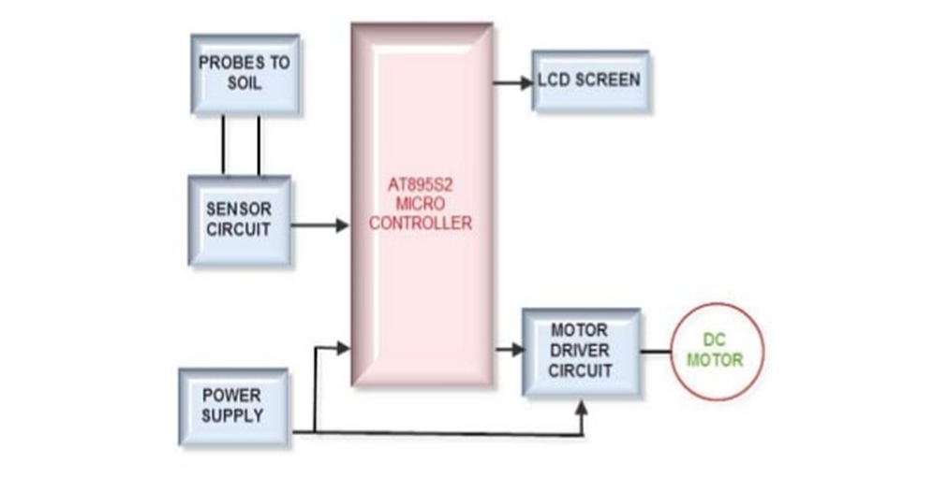

Fig 4.4.1: Block diagram of proposed system

### 4.2 Block Diagram Description

The block diagram of the project shows the all the hardware connection needed for the whole circuit to work. So, to overcome the drawbacks of existing system like high cost, difficult in maintenance and more wired connection. We introduce a new system which will have wireless connection between server and nodes. We introduce a new design of embedded web server making use of GSM network technology in the paper. Compared to the wired link webserver system. This system is characterized by having no wires between the web server and terminal nodes. These systems have lower cost and having more flexibility of the network topology. For every node we will use separate GSM trans-receiver to transmit the details to server nodes. Water irrigation control based on microcontroller and internet of things. By internet of things, we mean that it has the ability to analyses and distribute data that can be used as information and knowledge. Internet of things improves distribution of world’s resources to those who need it the most. In agricultural farm we use water irrigation is monitored by using sensor like. Soil moisture sensor and water level sensor are connected to Arduino UNO board through jumper wires and breadboard, connections have been provided in this section only. Soil moisture sensor will sense the dankness of soil and through WSN the data will be transferred to actuators to act upon that data. A threshold value has been set, both minimum and maximum, so that whenever the measured value crosses the predefined threshold value the motor will be switched on/off automatically. Same working goes with water level sensor in which a minimum and maximum threshold value has been set so that whenever the measured value of water level crosses the predefined threshold value the motor will be switched on/off automatically to fill the tank. An LCD is connected with Arduino and all the sensors to display the status of moisture content in soil and water level in tank. A 5V motor pump has been used for this project as this is a mini prototype model and Arduino that is used in this project can provide maximum of 5V power

**Arduino IDE**

## SOFTWARE USED

The Arduino Integrated Development Environment (IDE) is a cross platform application (for windows, Linux) that is written in functions from C and C++ It is used to write and upload programs to Arduino compatible boards, but also, with the help of third-party cores, other vendor development boards. The source code for the IDE is released under the GNU General Public License, version 2. The Arduino IDE supports the languages C and C++ using special rules of code structuring. The Arduino IDE supplies a software library from the Wiring project, which provides many common input and output procedures. User-written code only requires two basic functions, for starting the sketch and the main program loop, that are compiled and linked with a program stub main () into an executable cyclic executive program with the GNU toolchain, also included with the IDE distribution. The Arduino IDE employs the program argued to convert the executable code into a text file in hexadecimal encoding that is loaded into the Arduino board by a loader program in the board's firmware. By default, avrdude is used as the uploading tool to flash the user code onto official Arduino boards.] Arduino IDE is a derivative of the Processing IDE, however as of version 2.0, the Processing IDE will be replaced with the Visual Studio Code-based Eclipse Theia IDE framework. With the rising popularity of Arduino as a software platform, other vendors started to implement custom open-source compilers and tools (cores) that can build and upload sketches to other microcontrollers that are not supported by Arduino's official line of microcontrollers.

**Advantages**

## ADVANTAGES & DISADVANTAGES

Highly sensitive

Works according to the soil condition

Low cost and reliable circuit

Complete elimination of manpower

System can be switched into manual mode where required

### Disadvantages

This is applicable for only large farms.

Have limited life after installation due to the worsening of the plastic component in a hot, arid climate.

## CONCLUSION

By proper algorithm approach in designing the controller-based system for measurement and control of several crucial parameters for growth of plants, i.e., soil moisture, humidity, light intensity, temperature and many more is under ambit. The final results obtained from the evaluation after sensing of parametric values; needs to be definitive and precise. The system has to avoid quite a few many imperfections of the present systems by carefully handling the complexity, at the same time providing a flexible form of maintaining the environment. The continuously minimize costs of hardware and software, the expanded taken of electronic systems in agriculture, and a growing agricultural control system industry in several region of agricultural production, will result in control systems which we can rely upon, that will provide quality and quantity of production. Improvements will be made less expensive and more reliable sensors will be developed for use in agricultural production. The required technologies and components are available, many such systems have been independently developed. Also, integration of all these technologies is not an ominous test and can be successfully carried out.

## REFRENCE

[1] SMAJSTRLA, A.G.; KOO, R.C... (1 9 8 6). "Applied engineering in agriculture".

[2] CLEMENS, A.J. (1990). Feedback Control for Surface Irrigation Management in: Visions of the Future. ASAE Publication 04-90. American Society of Agricultural Engineers, St. Joseph, Michigan, pp.255-260.

[3] SCOTT MAC. KENZIE, The 8051-micro controller, second edition, pretice hall Inc., USA, (1995) pp. 81 - 94.

[4] SMAJSTRLA, A.G.; LOCASCIO, S.J. (1996). "Drip irrigation scheduling of tomato",12(3):312-319

[5] JOHN B PEATMEN, Design with micro controllers, McGraw Hill, USA, (1996).

[6] Introduction to LCD programming tutorial by CRIAG STEINER (1997) by Vault information services LLC.